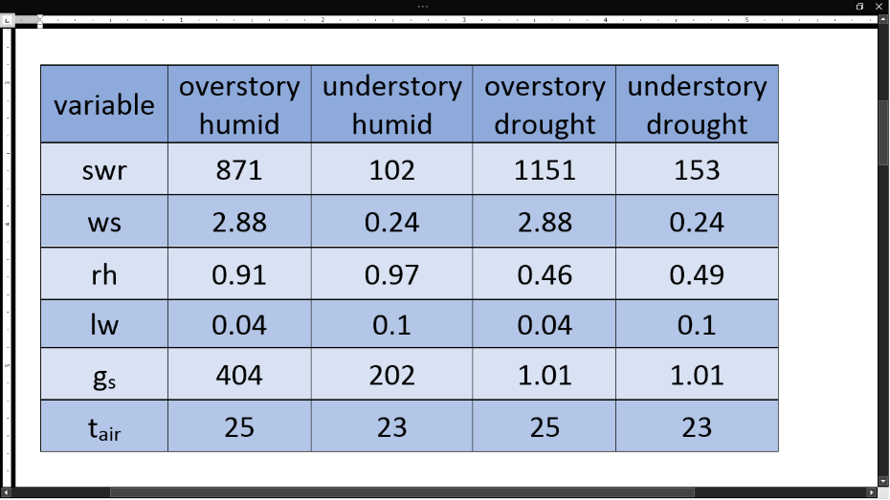0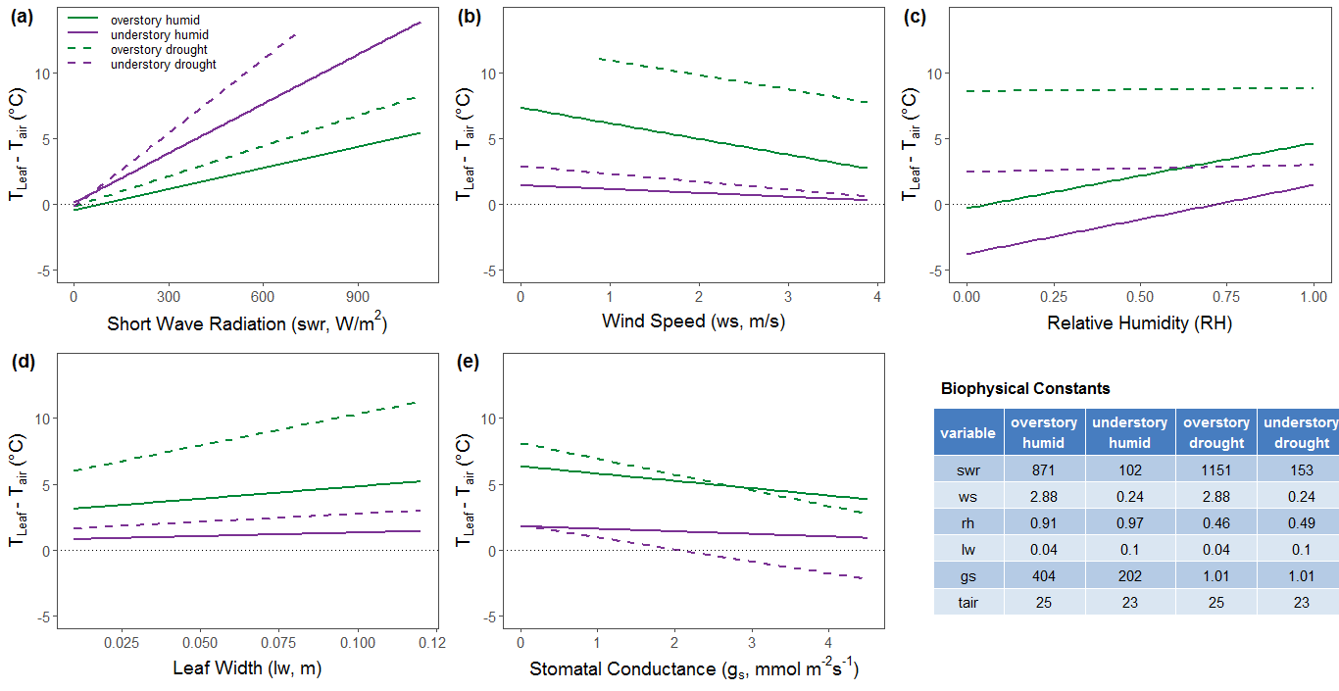

|  |  |  |  |  |
| --- | --- | --- | --- | --- |
| variable | overstory  humid | understory  humid | overstory drought | understory drought |
| swr | 871 | 102 | 1151 | 153 |
| ws | 2.88 | 0.24 | 2.88 | 0.24 |
| rh | 0.91 | 0.97 | 0.46 | 0.49 |
| lw | 0.04 | 0.1 | 0.04 | 0.1 |
| gs | 404 | 202 | 1.01 | 1.01 |
| tair | 25 | 23 | 25 | 23 |

